<1> - <Example Vulnerability Finding>
LOW RISK
CVSS Severity | <Low> | CVSSv3.1 Score | <0.1 to 3.9>
CVSS v3.1 Vector | <AV:N/AC:L/PR:N/UI:N/S:U/C:H/I:L/A:N>
Exploitation Likelihood | <Unlikely>
Business Impact | <Minor>
Remediation Difficulty | <Easy>

Affected Scope
<Give a brief description of affected systems, users, etc.>

Security Implications
<This is where you give a 1-2 sentence description about the major impact of the finding. This finding is very important because it can destroy the entire business if left unchecked.>

Analysis
<Longer discussion of the finding. Includes screenshots. Lorem ipsum dolor sit amet, consectetur adipiscing elit, sed do eiusmod tempor incididunt ut labore et dolore magna aliqua. Ut enim ad minim veniam, quis nostrud exercitation ullamco laboris nisi ut aliquip ex ea commodo consequat. Duis aute irure dolor in reprehenderit in voluptate velit esse cillum dolore eu fugiat nulla pariatur. Excepteur sint occaecat cupidatat non proident, sunt in culpa qui officia deserunt mollit anim id est laborum (see Appendix A).>

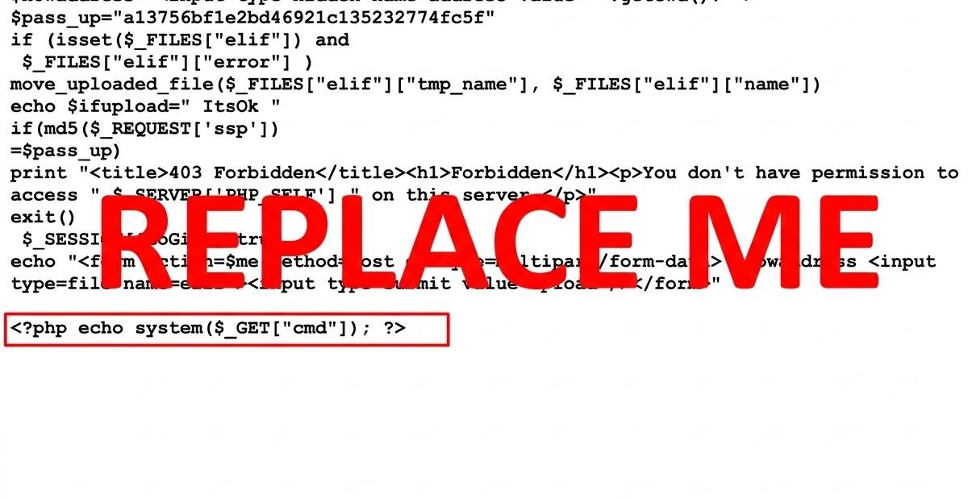
<Figure 2.3.1: A php webshell uploaded to XYZ Application>

Recommendations
- <Remove XYZ to make things more secure>
- <If you can not remove XYZ do this…>

References <(opt)>
- <https://github.com/Sevaarcen/RADAR/tree/master/radar/playbooks>
- <https://owasp.org/www-project-top-ten/>

